Kotlin – GeoLocation
Creation Process

Open Android Studio and create a new project. Name it BasicGeoLocation. Make sure Include Kotlin Support is checked and click Next
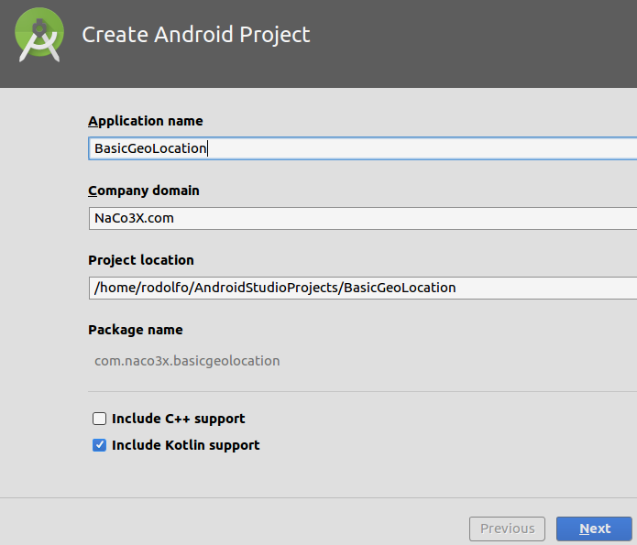
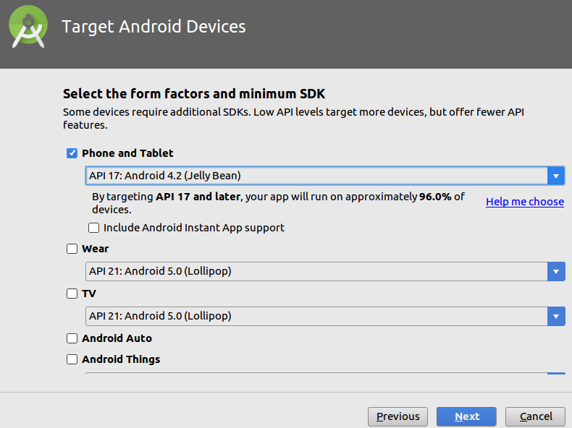

Select the device (Phone and Tablet) and the API level of your target device and click Next

Select an Empty Activity
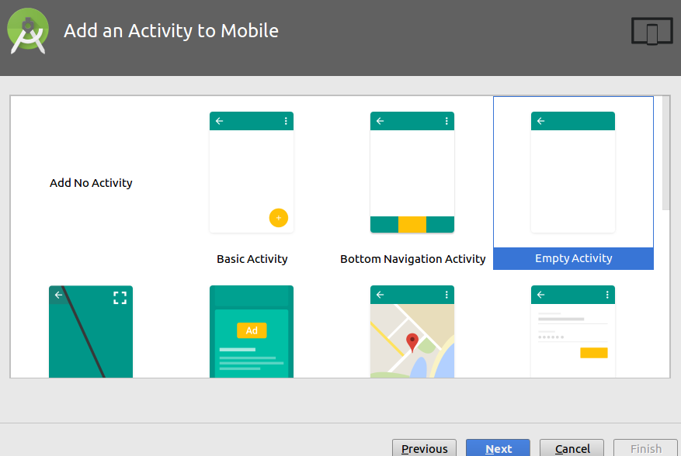
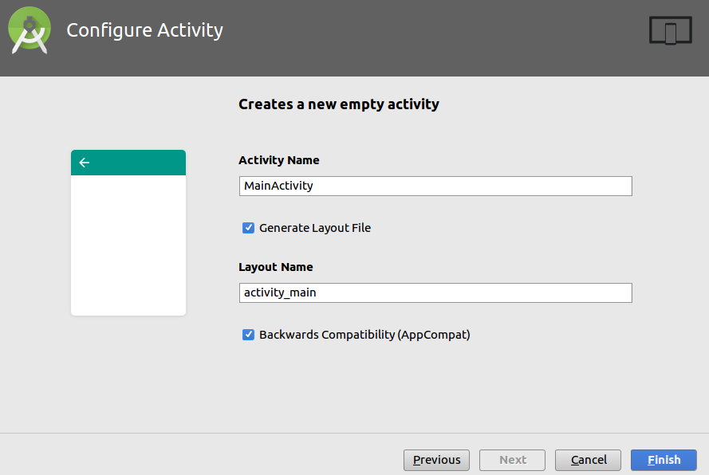

click Next and name it MainActivity (the default) and click Finish

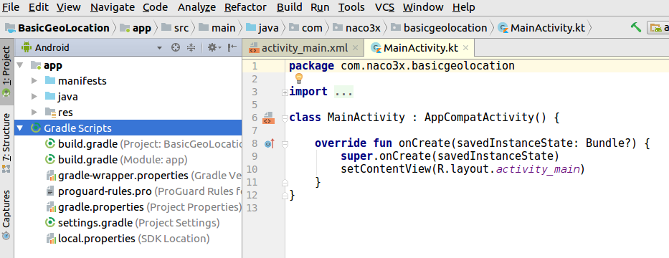
You will see a project tree similar to this

If you plan on using a version control system like GitHub, make sure you have an account at github.com and follow these steps to create the “master” branch to start with:

Go to File -> Settings -> Version Control -> GitHub. Enter your email and password and click on OK button.
Then go to VCS -> Import into Version Control -> Share Project on GitHub. Enter Repository name, Description and click Share button.
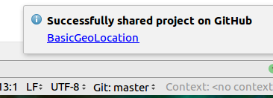
Take all the defaults. You will receive the message:
Notice at the bottom that now you have a Git entry in the status bar with the branch you are working with

It is a good idea to access the local Git using a Terminal to check on its status:

- Hit Ctl-T and change directory to the root of the BasicGeoLocation project
$ cd /home/Rodolfo/AndroidStudioProjects/BasicGeoLocation

- Type $git status. You will be informed of which branch you are working with and the status of your commits and pushes. Obviously at this point your local branch “master” is up-to-date with your remote branch “origin/master”.
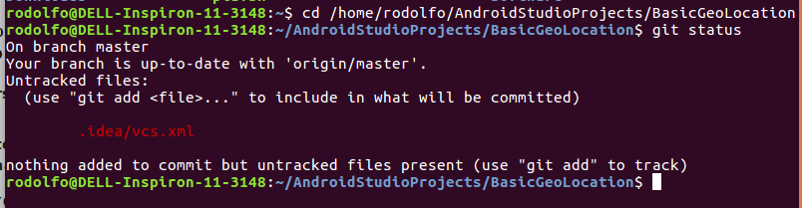
Notice that the remote (GitHub.com) version is called ‘origin’.
Keep in mind that you now have two versions of your files, and that any changes to one, will have to be committed locally and then PUSHED to the other side.

I highly recommend to ALWAYS work on your local version using Android Studio, not the remote version, and when you are happy with your changes, commit locally, and then push to origin. We will do it step by step.

So let’s create our first branch by clicking on the Git: master box at the bottom-right of the Android Studio IDE. You get the following options:
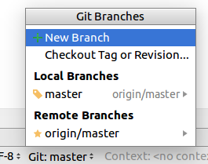
You can see the two versions of your files under Local and Remote Branches.
Notice that the local master is synchronized with the remote master by the origin/master entry to its right.

Click on +New Branch to create our new branch

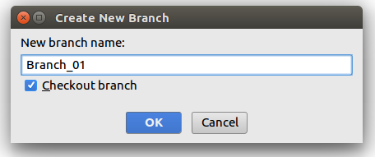
Name the new branch Branch_01 (or any name that makes sense to you and your project).
Make sure to select Checkout branch.

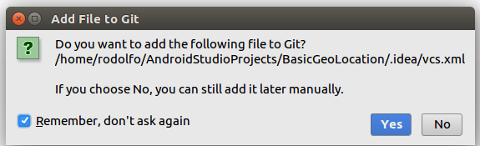
Select Yes when asked if the vcs.xml file should be version-controlled.

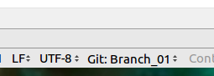
You will see that the current version is now the new branch

Let’s get started with the app.
As you can imagine, we need to add a couple of entries in our manifest to allow for Geolocation.

Include the following lines:

<uses-permission android:name="android.permission.ACCESS_FINE_LOCATION" />
<uses-permission android:name="android.permission.ACCESS_COARSE_LOCATION" />
<uses-permission android:name="android.permission.ACCESS_COARSE_UPDATES" />
<uses-permission android:name="android.permission.INTERNET" />
<uses-permission android:name="android.permission.WRITE_SETTINGS" />
<uses-feature android:name="android.hardware.location.gps" />
and add the following entry to the build.gradle (Module: app) file

implementation 'com.google.android.gms:play-services:11.8.0'

At this point our App should show a Hello Wordl! Message indicating that its very basic functionality is there and that our setup modifications did not crash it.
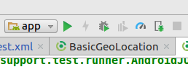
Click on the Run button and verify that is the case.

Make sure you have an android device connected to the USB of your computer or that you have a virtual device already configured.

If you see the Hello World! message on your device, we are in good shape and we can commit and push to our branch Branch_01.

Click on VCS → VCS Operations Popup. You will see the dialog window.
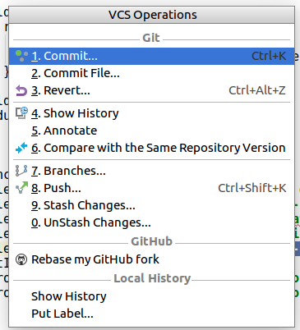
Select Commit. A new dialog window will show you all the files that have been modified since your last commit. Make sure all relevant files are included, write a commit message and click on the Commit button
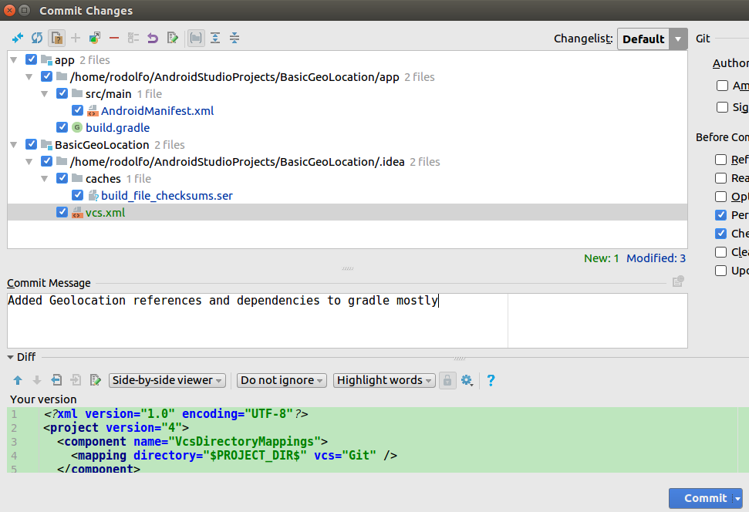

And now it’s time to PUSH your new branch to GitHub.
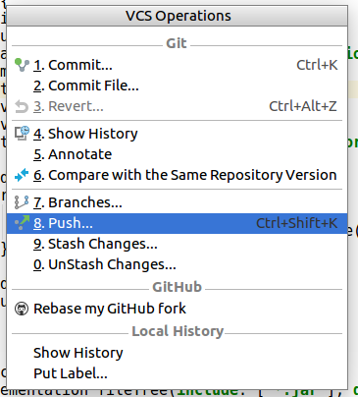
Click on VCS → VCS Operations Popup and select Push

Once your new branch has been created in GitHub, go to your terminal and check its status.
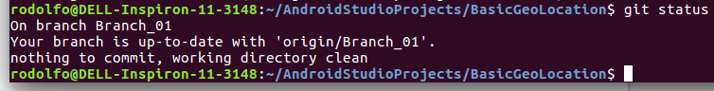
Both branches, local and remote are now on both your computer and the internet, and are in sync.

If at this point you want to update the master branch to the latest changes, click on Git: Branch_01 and select the local master branch. Select Checkout; the status bar will change to Git: master
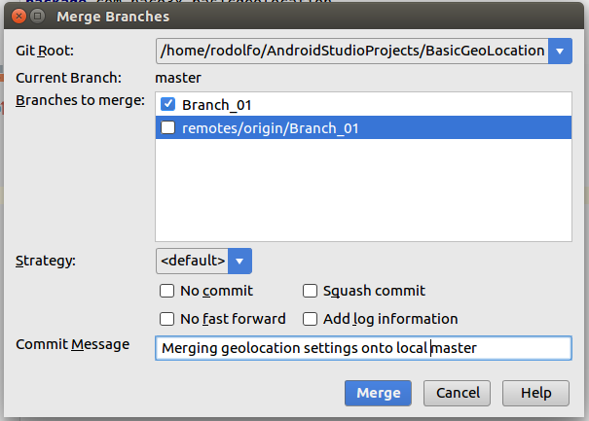
Click on VCS → Git → Merge Changes

Notice that your current branch is local ‘master’ and we will be merging the selected branch(es) onto it.

Write a commit message and click Merge

From your terminal get the git status.
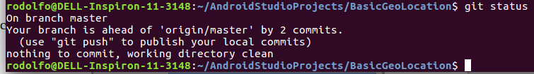
You can see that your local branch (master) is ahead of the remote master branch, so we have to first commit our local changes, and then push to the remote version.

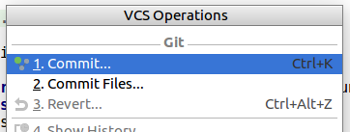
Click VCS → VCS Operations Popup and select Commit

And now it’s time to PUSH your new branch to GitHub.
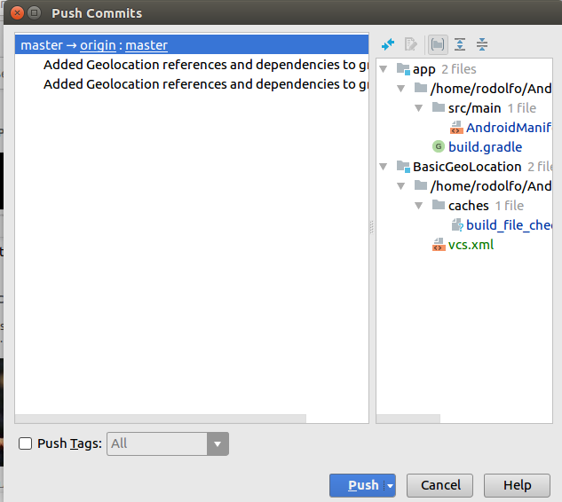
Click on VCS → VCS Operations Popup and select Push

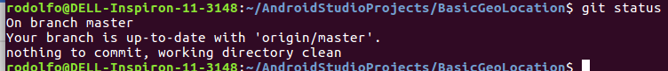
From your terminal check the Git status to make sure both local and remote masters are synchronized
and they are.

From here on out I will not make any references to Git branching since up to this point we have done all the basic Git activities and any new ones will be a repeat.

So let’s get the GeolocationActivity declared and worked on.
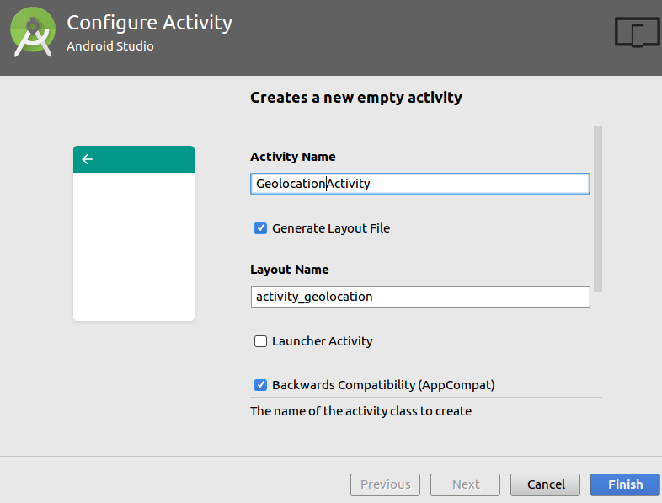
Right-click at the root of your app tree and select New → Activity → Blank Activity

Name it GeolocationActivity, select Generate Layout File and click on Finish

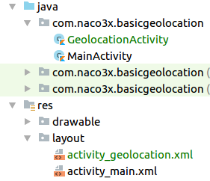

Two files will be created (in green on the figure), the GeolocationActivity.kt and its corresponding layout file activity_geolocation.xml

Edit the layout file and make it look like this:

<?xml version="1.0" encoding="utf-8"?>
<android.support.constraint.ConstraintLayout
xmlns:android="http://schemas.android.com/apk/res/android"
xmlns:app="http://schemas.android.com/apk/res-auto"
xmlns:tools="http://schemas.android.com/tools"
android:layout_width="match_parent"
android:layout_height="match_parent"
tools:context="com.naco3x.basicgeolocation.GeolocationActivity">
<TextView
android:id="@+id/geoTextView"
android:layout_width="wrap_content"
android:layout_height="wrap_content"
android:text="Hello World!"
app:layout_constraintBottom_toBottomOf="parent"
app:layout_constraintLeft_toLeftOf="parent"
app:layout_constraintRight_toRightOf="parent"
app:layout_constraintTop_toTopOf="parent" />
<Button android:id="@+id/geoGetButton"
android:text="Get"
android:layout_width="match_parent"
android:layout_height="wrap_content"
app:layout_constraintTop_toBottomOf="@+id/geoTextView" />
</android.support.constraint.ConstraintLayout>
Make sure the GeolocationActivity.kt has the following onCreate method:

class GeolocationActivity : AppCompatActivity() {
override fun onCreate(savedInstanceState: Bundle?) {
super.onCreate(savedInstanceState)
setContentView(R.layout.activity_geolocation)
geoGetButton.setOnClickListener {
try {
geoTextView.text = "You intended to get your location! Congrats!!"
//startLocationUpdates()
}
catch (e : SecurityException) {
}
}
}
}
Add the following button to the activity_main.xml file
<Button
android:id="@+id/btnstart"
android:layout_width="wrap_content"
android:layout_height="wrap_content"
android:layout_marginEnd="8dp"
android:layout_marginStart="8dp"
android:layout_marginTop="8dp"
android:text="Geolocation Activity"
app:layout_constraintEnd_toEndOf="parent"
app:layout_constraintStart_toStartOf="parent"
app:layout_constraintTop_toBottomOf="@+id/textView" />
So far we have a new activity and its corresponding layout, a button in our main activity, so let’s make this button start the new activity:

In the onCreate method of the MainActivity.kt code file do the following:

override fun onCreate(savedInstanceState: Bundle?) {
super.onCreate(savedInstanceState)
setContentView(R.layout.activity_main)
btnstart.setOnClickListener {
val intent = Intent(this, GeolocationActivity::class.java)
startActivity(intent)
}
}
observe that in Kotlin (provided the right imports) the instant you try to access the btnstart view, it automatically creates the import for the following synthetic class:

import kotlinx.android.synthetic.main.activity_main.*

If it doesn’t, make sure to include it at the top of the class.

